#### EXHIBIT A

## CITY OF DETROIT

BROWNFIELD REDEVELOPMENT AUTHORITY

BROWNFIELD PLAN FOR THE

BRUSH PARK SOUTH (PHASE 1)

REDEVELOPMENT PROJECT

Prepared by:

Richard A. Barr, Esq.

Honigman LLP

660 Woodward Avenue, Ste. 2290

Detroit, Michigan 48226

Phone: (313) 465-7308

Developer:

Brush Park South Phase I MR LLC

17800 Laurel Park Drive North, Ste. 200C

Livonia, Michigan 48152

January 7, 2019

**CITY OF DETROIT**

**BROWNFIELD REDEVELOPMENT AUTHORITY**

**BROWNFIELD PLAN**

TABLE OF CONTENTS

1. INTRODUCTION 1
2. GENERAL PROVISIONS
   1. Description of Eligible Property 2
   2. Basis of Eligibility 4
   3. Summary of Eligible Activities 4
   4. Estimate of Captured Taxable Value and Tax 6

Increment Revenues; Impact of Tax Increment

Financing on Taxing Jurisdictions

* 1. Plan of Financing; Maximum Amount 6

Of Indebtedness

* 1. Duration of Plan 7
  2. Effective Date of Inclusion 8
  3. Displacement/Relocation of Individuals 8

On Eligible Property

* 1. Local Brownfield Revolving Fund (LBRF) 8
  2. Brownfield Redevelopment Fund 8
  3. Developer’s Obligations, Representations and Warrants 8

1. ATTACHMENTS
   1. Site Map
   2. Legal Description(s)
   3. Project Description
   4. Supportive Letters
   5. Estimated Cost of Eligible Activities
   6. TIF Tables
   7. BSE&E Acknowledgement and Other Environmental Documents

H. Incentive Information Chart

I. INTRODUCTION

In order to promote the revitalization of environmentally distressed and blighted areas within the boundaries of the City of Detroit, Michigan (the “City”), the City has established the City of Detroit Brownfield Redevelopment Authority (the “DBRA”) pursuant to Michigan Public Act 381 of 1996, as amended (“Act 381”).

The primary purpose of this Brownfield Plan (“Plan”) is to promote the redevelopment of and private investment in certain “brownfield” properties within the City. Inclusion of property within this Plan will facilitate financing of environmental response and other eligible activities at eligible properties, and will also provide tax incentives to eligible taxpayers willing to invest in revitalization of eligible sites, commonly referred to as “brownfields.” By facilitating redevelopment of brownfield properties, this Plan is intended to promote economic growth for the benefit of the residents of the City and all taxing units located within and benefited by the DBRA.

This Plan is intended to apply to the eligible property identified in this Plan and, if tax increment revenues are proposed to be captured from that eligible property, to identify and authorize the eligible activities to be funded by such tax increment revenues.

This Plan is intended to be a living document, which may be modified or amended in accordance with the requirements of Act 381, as necessary to achieve the purposes of Act 381. The identification or designation of a developer or proposed use for the eligible property shall not necessitate an amendment of this Plan, affect the application of this Plan to the eligible property or impair the rights available to the DBRA under this Plan. The applicable sections of Act 381 are noted throughout the Plan for reference purposes.

This Plan describes the Project to be completed (see Attachment C) and contains all the information required by Section 13(2) of Act 381.

**II. GENERAL PROVISIONS**

# A. Description of the Eligible Property (Section 13 (2)(h)) and the Project

The property comprising the eligible property consists of approximately 3.406 acres of land within nine tax parcels, as well as the adjacent rights of way. Seven of the tax parcels each qualify as a facility and two of the tax parcels are each adjacent and contiguous to a tax parcel which is a facility. The property comprising the eligible property and all tangible personal property located thereon will comprise the eligible property and is referred to herein as the “Property.”

Attachment A includes a site map of the Property. The Property is located in the Brush Park area, west of Brush Street, north of Winder Street and south of the east-west alley between Adelaide and Alfred Street from Brush Street to John R Street.

The eligible property will include all tangible personal property to be located on the real property. Parcel information is outlined below.

|  |  |
| --- | --- |
| Address | 2515 Brush Street, tax parcel 01000598-604  2555 Brush Street, tax parcel 01000605-8  2621 Brush Street, tax parcel 01000635-8  251 Adelaide Street, tax parcel 01000632  254 Adelaide Street, tax parcel 01000609-11  257 Adelaide Street, tax parcel 01000633-4  269 Winder Street, tax parcel 01000595.002L  281 Winder Street, tax parcel 01000596  291 Winder Street, tax parcel 01000597 |
| Parcel ID | See above |
| Owner | City of Detroit |
| Legal Description | LAND SITUATED IN THE COUNTY OF WAYNE, CITY OF DETROIT, STATE OF MICHIGAN, IS DESCRIBED AS FOLLOWS:              AND ALL ADJACENT RIGHTS OF WAY. |

Brush Park South Phase I MR LLC or its affiliate(s) (the “Developer”) will acquire the Property from the City of Detroit, following which it (or its affiliate) and RS Limited Dividend Housing Association, LLP (“LDHA”), will construct three mixed-income apartments buildings that will include approximately 149 apartments and 600 square feet of retail space. The three buildings and the land under and adjacent to the buildings (the “Condo Land”) are expected to be owned within a condominium that will have two or more condominium units, one of which will be owned by the Developer or its affiliate and one of which will be owned by the LDHA. Approximately 91 of the apartments will be within the condominium unit owned by the Developer and the remaining 58 apartments will be rented as affordable apartments with rents restricted and otherwise subject to various requirements to assure their occupancy by residents who satisfy affordable housing criteria.

A portion of the remainder of the Property will be used for parking that will remain in place indefinitely for use by tenants of the new apartment buildings as well as additional parking that will be available until alternative, permanent alternative parking becomes available either on the east side of Brush or at other locations. It is expected that the alternative parking will not be available for at least several years.

It is currently anticipated that construction, including eligible activities, will begin in the Spring of 2019 and be completed by early 2021. The project description provided herein is a summary of the proposed development at the Property at the time of the adoption of the Plan.  The actual development may vary from the project description provided herein, without necessitating an amendment to this Plan, so long as such variations are not material and arise as a result of changes in market and/or financing conditions affecting the project and/or are related to the addition or immaterial removal of amenities to the project.  All such changes, as determined by DBRA in its sole discretion, to the project description are subject to the approval of the DBRA staff and shall be consistent with the overall nature of the proposed development, its proposed public purpose, and the purposes of Act 381.

In large part due to the project’s importance to providing mixed income housing opportunities in the reviving Brush Park area, the project has received extensive support and approvals from the City of Detroit and its affiliates, including the City’s Housing and Revitalization Department (HRD), the City’s Planning and Development Department (PDD), the City Planning Commission, and the Historic District Commission; the allocation of HOME funds and CDBG funds, and allocation of federal low income tax credits.

Attachment C provides a detailed description of the project to be completed at the Property (the “Project”) and Attachment D includes letters of support for the Project.

**B. Basis of Eligibility (Section 13(2)(h) and Section 2(p))**

The Property is considered “eligible property” as defined by Act 381, Section 2, because (a) it was previously utilized for a commercial purpose and/or public purpose; (b) it is located within the City of Detroit, a qualified local governmental unit under Act 381; and (c) it is a facility under Part 201 due to the presence of metals, PNAs, PCBs soil and fill or adjacent and contiguous to a facility and the development of the adjacent or contiguous parcels is estimated to increase the captured taxable value of the remainder of the eligible property.

**C. Summary of Eligible Activities and Description of Costs (Section 13(2)(a), (b))**

The “eligible activities” that are anticipated to be carried out at the Property for the Project are considered “eligible activities” as defined by Section 2(o) of Act 381, because they include baseline environmental assessment activities, due care activities, additional response activities, site preparation, infrastructure improvements, development and preparation of a brownfield plan and work plan, brownfield plan implementation and interest.

A summary of the eligible activities and the estimated cost of each eligible activity intended to be paid for with Tax Increment Revenues from the Property are shown in the table attached hereto as Attachment E. A response activity plan has been prepared for the removal, disposal and backfill of solid waste or impacted fill and soils together with any encountered impacted groundwater, all of which will be disposed of off-site during construction of the Project. Due to the historic fill and urban conditions on the Property, the confirmed presence of hazardous substances in a substantial portion of the soil borings, and disposal facility requirements, the removed fill and shallow soils are expected to need to be disposed at a Type II disposal facility. Deeper native soils (including that which may be required to be removed for construction of underground detention and elevator pits) may be disposed of as clean material, depending upon test results. Unknown quantities of groundwater are expected to be encountered during dewatering and other construction activities with resulting costs being expected to be incurred for collection, testing and disposal of groundwater depending upon test results in accordance with law.

The eligible activities include response activities to properly manage contaminated soils on the Property; geotechnical evaluations; removal and replacement of fill material; storm water management features; and improvements in the rights of way of adjacent streets and alleys. The eligible activities described in Attachment E are not exhaustive. Subject to the approval of DBRA staff in writing, additional eligible activities may be carried out at the Property, without requiring an amendment to this Plan, so long as such eligible activities are permitted by Act 381 and the cost of such eligible activities does not exceed the total costs stated in Attachment E.

Unless otherwise agreed to by the DBRA, all eligible activities will commence within than eighteen months after the date the governing body approves this Plan. All eligible activities will be completed within three years after approval of the Michigan Strategic Fund work plan, if applicable, or three years after execution of the Reimbursement Agreement (as that term is defined below). Any long-term monitoring or operation and maintenance activities or obligations that may be required will be performed in compliance with the terms of this Plan and any documents prepared pursuant to this Plan.

The Developer desires to be reimbursed for the costs of eligible activities incurred by it or its affiliates (including but not limited to the LDHA) and interest thereon as described below. Some eligible activities may commence prior to the adoption of this Plan and to the extent permitted by Act 381 shall be reimbursable pursuant to the Reimbursement Agreement. Tax increment revenue generated by the Property will be captured by the DBRA and used to reimburse the cost of the eligible activities completed on the Property pursuant to the terms of a Reimbursement Agreement to be executed by the DBRA and the Developer after approval of this Plan (the “Reimbursement Agreement”), to the extent permitted by Act 381. In the event this Plan contemplates the capture of tax increment revenue derived from “taxes levied for school operating purposes” (as defined by Section 2(uu) of Act 381 and hereinafter referred to as “School Taxes”), the Developer acknowledges and agrees that DBRA’s obligation to reimburse the Developer for the cost of eligible activities with tax increment revenue derived from Local Taxes, or Specific Taxes that are considered Local Taxes (as these capitalized terms are defined by Act 381) is contingent upon: (i) the Developer receiving at least the initial applicable work plan approvals by the Michigan Strategic Fund and the Michigan Department of Environmental Quality, as may be required pursuant to Act 381, within 180 days after the date this Plan is approved by the governing body, or such other date as the DBRA may agree to in writing; or (ii) the Developer providing the DBRA with evidence, satisfactory to DBRA, that the Developer has the financial means to complete the project without the capture of, and subsequent reimbursement with, the contemplated School Taxes.

The costs listed in Attachment E are estimated costs and may increase or decrease depending upon the nature and extent of environmental contamination and other unknown conditions encountered on the Property. The actual cost of those eligible activities encompassed by this Plan that will qualify for reimbursement from tax increment revenues of the DBRA from the Property shall be governed by the terms of the Reimbursement Agreement. No costs of eligible activities will be qualified for reimbursement except to the extent permitted in accordance with the terms and conditions of the Reimbursement Agreement and Act 381. The Reimbursement Agreement and this Plan will dictate the total cost of eligible activities subject to payment or reimbursement, provided that the total cost of eligible activities subject to payment or reimbursement under the Reimbursement Agreement shall not exceed the estimated costs set forth in Attachment E. As long as the total costs are not exceeded, line item costs of eligible activities may be adjusted after the date this Plan is approved by the governing body, to the extent the adjustments do not violate the terms of the approved MDEQ or MSF work plan.

D. Estimate of Captured Taxable Value and Tax Increment Revenues (Section 13(2)(c)); Beginning Date of Capture of Tax Increment Revenues (Section 13(2)(f); Impact of Tax Increment Financing on Taxing Jurisdictions (Section 13(2)(g))

This Plan anticipates the capture of tax increment revenues to reimburse the Developer for the costs of eligible activities under this Plan in accordance with the Reimbursement Agreement. Subject to Section 13(b)(16) of Act 381, a table of estimated tax increment revenues to be captured is attached to this Plan as Attachment F.

Tax increments are projected to be captured and applied to (i) reimbursement of eligible activity costs and payment of DBRA administrative and operating expenses, (ii) make deposits into the State Brownfield Redevelopment Fund, and (iii) make deposits into the DBRA’s Local Brownfield Revolving Fund, as follows:



In addition, the following taxes are projected to be generated but shall not be captured during the life of this Plan:

|  |  |  |  |  |
| --- | --- | --- | --- | --- |
|  |  |  |  |  |
| City Debt |  | $861,992 |
| School Debt |  | $1,600,842 |
| DIA Tax |  | $24,628 |
| Zoo Tax |  | $12,314 |
| Total Debt Millages |  | $2,499,776 |

In no event shall the duration of this Plan exceed thirty-five years following the date of the governing body’s resolution approving this Plan, nor shall the duration of the tax capture exceed the lesser of the period authorized under subsection (5) of Section 13 of Act 381 or 30 years. Further, in no event shall the beginning date of the capture of tax increment revenues be later than five years after the date of the governing body’s resolution approving this Plan. The beginning date of the capture of tax increment revenues shall be the 2021 tax year (commencing with the Summer 2021 property taxes).

E. Plan of Financing (Section 13(2)(d)); Maximum Amount of Indebtedness (Section 13(2)(e))

The eligible activities are to be financed solely by the Developer. The DBRA will reimburse the Developer for the cost of approved eligible activities, but only from tax increment revenues generated from the Property. No advances have been or shall be made by the City or the DBRA for the costs of eligible activities under this Plan.

All reimbursements authorized under this Plan shall be governed by the Reimbursement Agreement. The inclusion of eligible activities and estimates of costs to be reimbursed in this Plan are intended to authorize the DBRA to fund such reimbursements and does not obligate the DBRA or the City to fund any reimbursement or to enter into the Reimbursement Agreement providing for the reimbursement of any costs for which tax increment revenues may be captured under this Plan, or which are permitted to be reimbursed under this Plan. The amount and source of any tax increment revenues that will be used for purposes authorized by this Plan, and the terms and conditions for such use and upon any reimbursement of the expenses permitted by this Plan, will be provided solely under the Reimbursement Agreement contemplated by this Plan.

Unless otherwise agreed upon by the Developer, the DBRA, and the State of Michigan, the DBRA shall not incur any note or bonded indebtedness to finance the purposes of this Plan.

Interest shall be paid under this Plan as provided in the Reimbursement Agreement, provided that to the extent that the Michigan Strategic Fund or Michigan Department of Environmental Quality does not approve the payment of interest on an eligible activity with school taxes, interest shall not be paid under this Plan from school taxes with respect to the cost of such eligible activity. Unless otherwise agreed upon by the Developer, the DBRA, and the State of Michigan, the DBRA may approve interest on the local portion of the reimbursement to the extent that the projected internal rate of return to the Developer does not exceed twenty (20%), as more specifically stated in the Reimbursement Agreement.

Reimbursements under the Reimbursement Agreement shall not exceed the cost of eligible activities (including interest) permitted under this Plan.

F. Duration of Plan (Section 13(2)(f))

Subject to Section 13b(16) of Act 381, the beginning date of capture of tax increment revenues for each eligible property shall occur in accordance with the Tax Increment Financing (TIF) table described in Exhibit F. In no event, however, shall this Plan extend beyond the maximum term allowed by Section 13(2)(f) of Act 381 for the duration of this Plan.

Furthermore, this Plan, or any subsequent amendment thereto, may be abolished or terminated in accordance with Section 14(8) of Act 381 in the event of any of the following:

a. The governing body may abolish this Plan (or any subsequent amendment thereto) when it finds that the purposes for which this Plan was established have been accomplished.

b. The governing body may terminate this Plan (or any subsequent amendment thereto) if the project for which eligible activities were identified in this Plan (or any subsequent amendment thereto) fails to occur with respect to the eligible property for at least two (2) years following the date of the governing body resolution approving this Plan (or any subsequent amendment thereto), provided that the governing body first does both of the following: (i) gives 30 days’ written notice to the Developer at its last known address by certified mail or other method that documents proof of delivery attempted; and (ii) provides the Developer with an opportunity to be heard at a public meeting.

Notwithstanding anything in this subsection to the contrary, this Plan (or any subsequent amendment thereto) shall not be abolished or terminated until the principal and interest on bonds, if any, issued under Section 17 of Act 381 and all other obligations to which the tax increment revenues are pledged have been paid or funds sufficient to make the payment have been identified or segregated.

G. Effective Date of Inclusion in Brownfield Plan

The Property will become a part of this Plan on the date this Plan is approved by the governing body.

**H. Displacement/Relocation of Individuals on Eligible Property (Section 13(2)(i-l))**

There are no persons or businesses residing on the eligible property and no occupied residences will be acquired or cleared, therefore there will be no displacement or relocation of persons or businesses under this Plan.

**I. Local Brownfield Revolving Fund (“LBRF”) (Section 8; Section 13(2)(m))**

The DBRA has established a Local Brownfield Revolving Fund (LBRF). The LBRF will consist of all tax increment revenues authorized to be captured and deposited in the LSRRF, as specified in Section 13(5) of Act 381, under this Plan and any other plan of the DBRA. It may also include funds appropriated or otherwise made available from public or private sources.

The amount of tax increment revenue authorized for capture and deposit in the LBRF is estimated at $2,068,674. All funds, if any, deposited in the LBRF shall be used in accordance with Section 8 of Act 381.

In addition, the Developer intends to request a loan of approximately $1,000,000 from the LBRF from funds currently held by it. The terms and conditions of the loan will be the subject of a loan agreement and other agreements between the DBRA and the Developer.

**J. Brownfield Redevelopment Fund (Section 8a; Section 13(2)(m))**

The DBRA shall pay to the Department of Treasury at least once annually an amount equal to 50% of the taxes levied under the state education tax, 1993 PA 331, MCL 211.901 to 211.906, that are captured under this Plan for up to the first twenty-five (25) years of the duration of capture of tax increment revenues for each eligible property included in this Plan. If the DBRA pays an amount equal to 50% of the taxes levied under the state education tax, 1993 PA 331, MCL 211.901 to 211.906, on a parcel of eligible property to the Department of Treasury under Section 13b(14) of Act 381, the percentage of local taxes levied on that parcel and used to reimburse eligible activities for the Project under this Plan shall not exceed the percentage of local taxes levied on that parcel that would have been used to reimburse eligible activities for the Project under this Plan if 50% of the taxes levied under the state education tax, 1993 PA 331, MCL 211.901 to 211.906, on that parcel were not paid to the Department of Treasury under Section 13b(14) of Act 381.

**K. Developer’s Obligations, Representations and Warrants**

The Developer and its affiliates shall comply with all applicable laws, ordinances, executive orders, or other regulations imposed by the City or any other properly constituted governmental authority with respect to the Property and shall use the Property in accordance with this Plan.

The Developer, at its sole cost and expense, shall be solely responsible for and shall fully comply with all applicable federal, state, and local relocation requirements in implementing this Plan.

The Developer represents and warrants that a Phase I Environmental Site Assessment (“ESA”), and if appropriate, a Phase II ESA, baseline environmental assessment, and due care plan, pursuant to Part 201 of Michigan’s Natural Resources and Environmental Protection Act (MCL 324.20101 *et seq.*), have been performed on the Property (“Environmental Documents”). Attached hereto as Attachment G is the City of Detroit’s Department of Buildings, Safety, Engineering and Environmental acknowledgement of its receipt of the Phase I ESA, and if appropriate, the Phase II ESA.

The Developer further represents and warrants that the Project does not and will not include a City of Detroit Land Bank Authority, Wayne County Land Bank Authority or State of Michigan Land Bank financing component.

The Developer has applied or will apply for a property tax abatement under the Commercial Rehabilitation Act. If approved, the abatement will reduce the property tax obligations of the Property for the periods applicable under the abatement certificate, thereby reducing the amount of tax increment revenues available pursuant to this Plan.

Except as otherwise agreed to by the DBRA, any breach of a representation or warranty contained in this Plan shall render the Plan invalid, subject to the Developer’s reasonable opportunity to cure as described in the Reimbursement Agreement.

**III. ATTACHMENTS**

**Attachment A**

**Site Map**

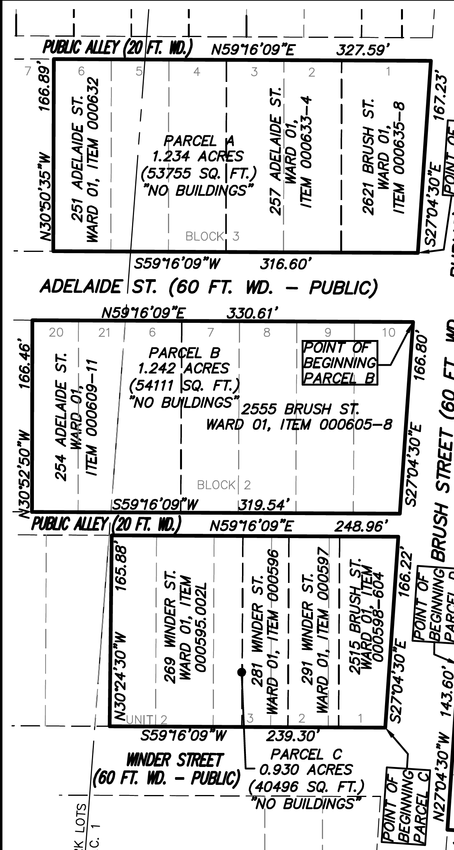

Site map subject to change without amendment of Brownfield Plan.

**ATTACHMENT B**

**Legal Descriptions of Eligible Property to which the Plan Applies**

Land situated in the City of Detroit, County of Wayne and State of Michigan, more particularly described as follows:

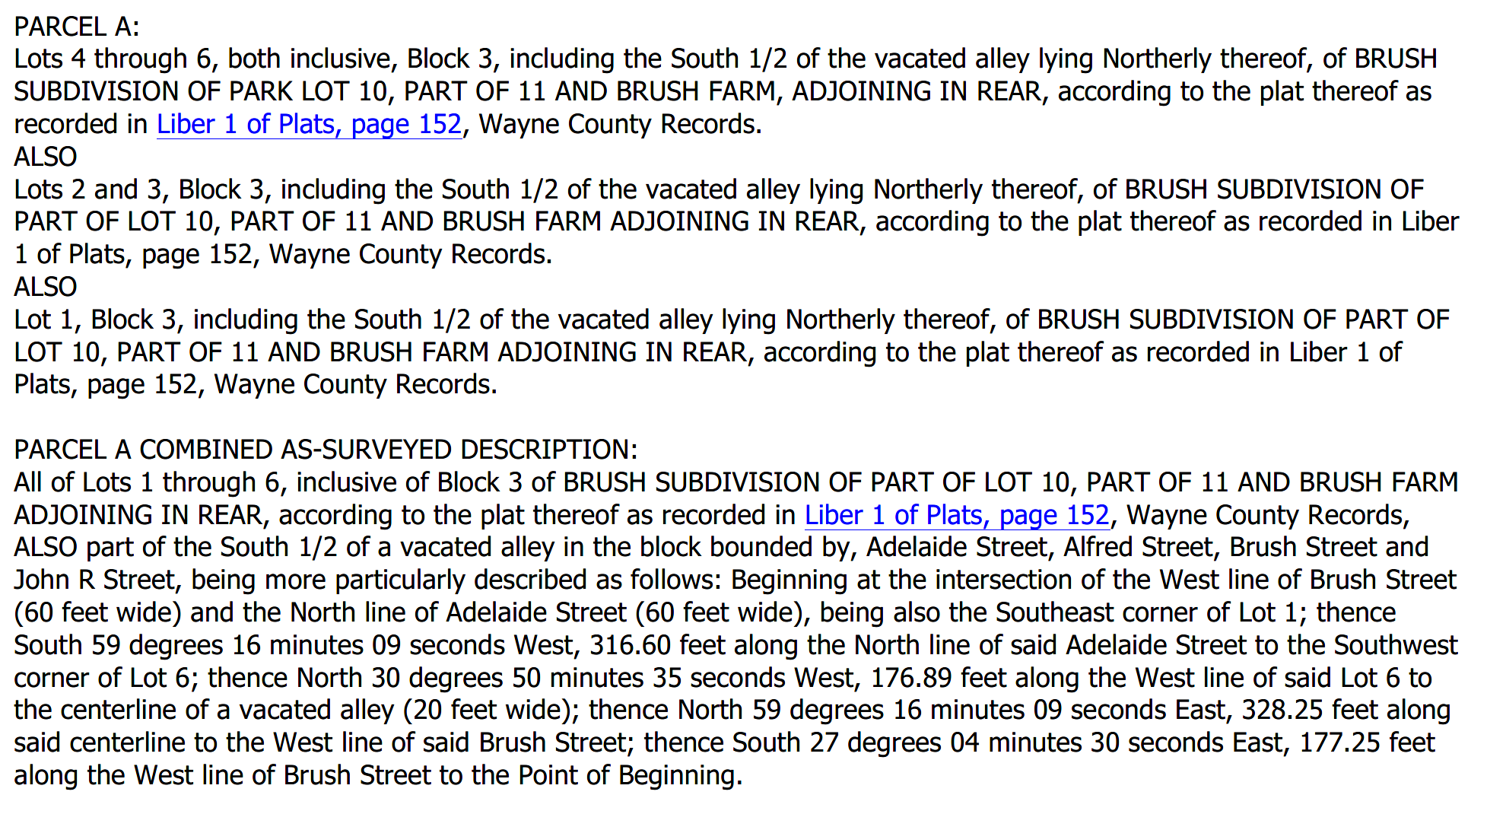

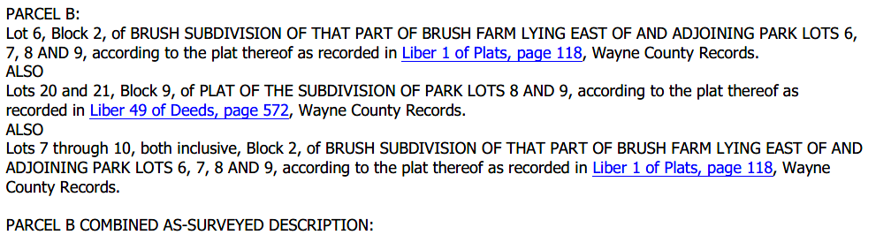

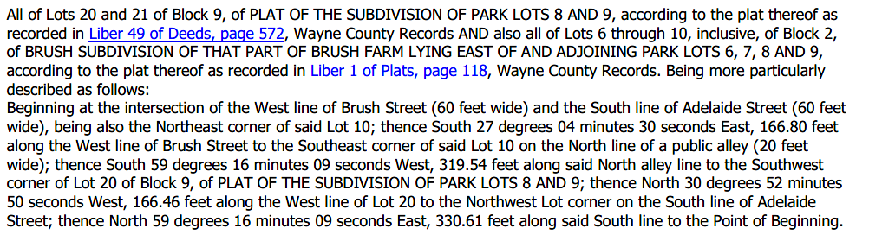

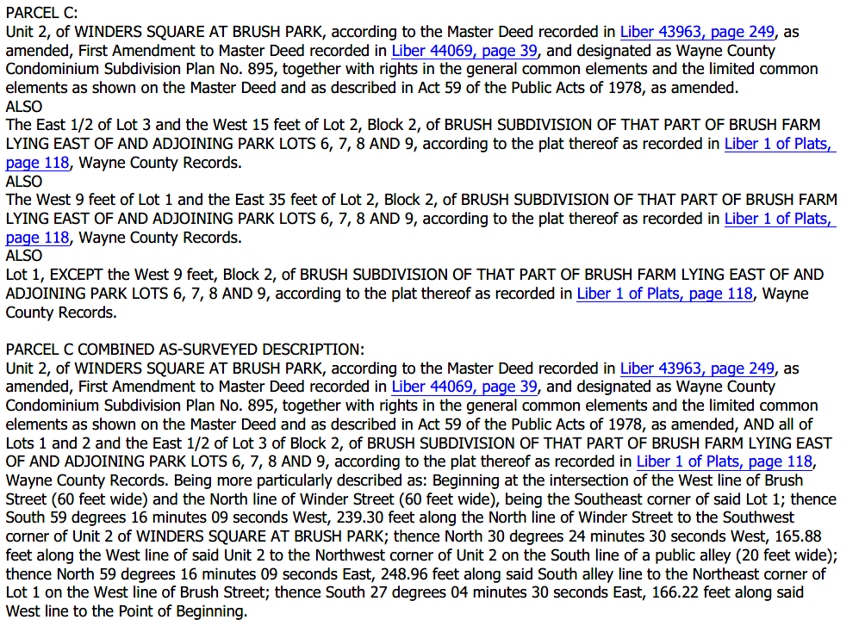

Also described as:

2515 Brush Street, tax parcel 01000598-604

2555 Brush Street, tax parcel 01000605-8

2621 Brush Street, tax parcel 01000635-8

251 Adelaide Street, tax parcel 01000632

254 Adelaide Street, tax parcel 01000609-11

257 Adelaide Street, tax parcel 01000633-4

269 Winder Street, tax parcel 01000595.002L

281 Winder Street, tax parcel 01000596

291 Winder Street, tax parcel 01000597

**ATTACHMENT C**

**Project Description**

Brush Park South Owner LLC and its affiliate(s) (the “Developer”) intends to redevelop approximately 3.406 acres of land located west of Brush Street, north of Winder Street and south of the east-west alley between Adelaide and Alfred Street from Brush Street to John R Street, for the construction by it and RS Limited Dividend Housing Associates, LLP (“LDHA”) of three mixed-income apartments buildings that will include approximately 149 apartments and 600 square feet of retail space. The three buildings and the land under and adjacent to the buildings (the “Condo Land”) is expected to be owned within a condominium that will have two condominium units, one of which will be owned by the Developer or its affiliate and one of which will be owned by the LDHA. Approximately 91 of the apartments will be within the condominium unit owned by the Developer and the remaining 58 apartments will be rented as affordable apartments with rents restricted and otherwise subject to various requirements to assure their occupancy by residents who satisfy affordable housing criteria.

A portion of the remainder of the Property will be used for parking that will remain in place indefinitely for use by tenants of the new apartment buildings as well as additional parking that will be available until alternative, permanent alternative parking becomes available either on the east side of Brush or at other locations. It is expected that the alternative parking will not be available for at least several years.

As project plans are subject to revision, the actual dimensions and capacities of all buildings and improvements may vary from this description. The estimated total capital investment is approximately $37 Million.

The Project is anticipated to create at least approximately 250 construction jobs during a 23 month construction period and an estimated 4 to 6 permanent full-time equivalent jobs related to property management. An unknown number of jobs are expected to be created by one or more businesses that located in the retail component of the project.

Preliminary eligible activities (e.g., engineering, planning, etc.) started in 2016. Construction is expected to start in February, 2019, be substantially completed by December, 2020 and be completed by early 2021.

Tentative Building Elevations (subject to change)

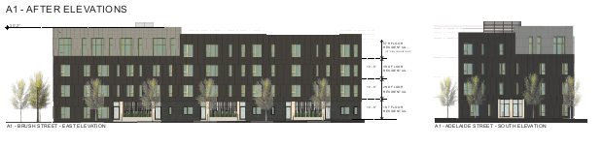

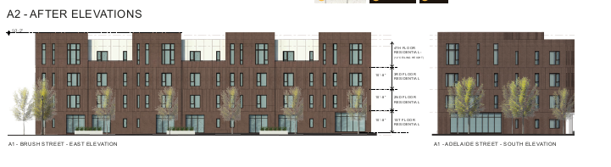

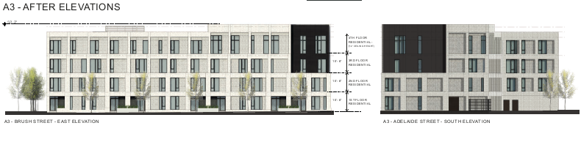

**ATTACHMENT D**

**Supportive Letters**

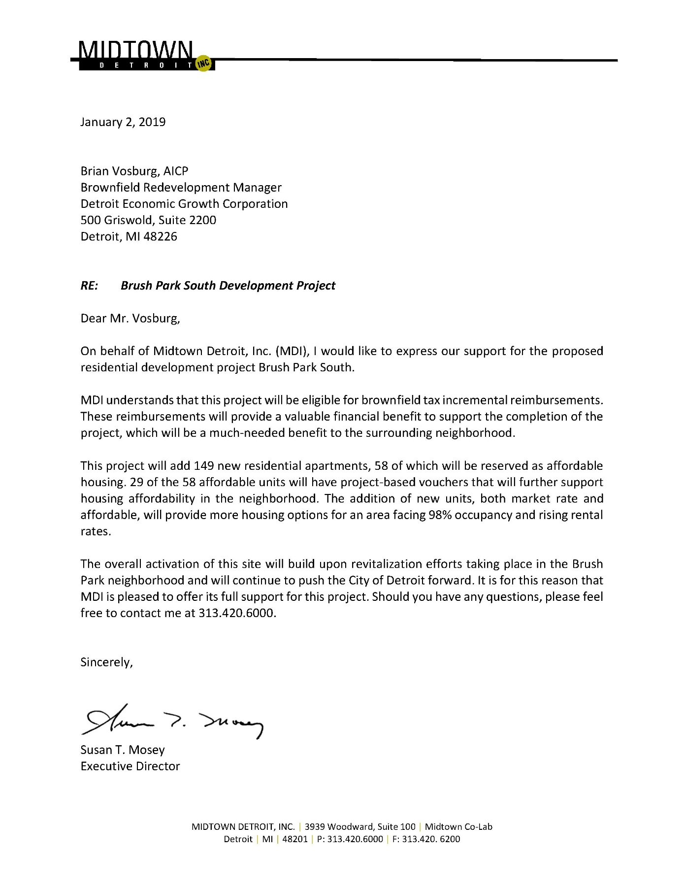

**ATTACHMENT E**

**Estimated Cost of Eligible Activities Tables**

The estimated total cost of eligible activities is $4,282,132. For informational purposes, the eligible activities are presented below based upon their expected characterization as “Department Specific Activities” or “MSF Activities”, provided that the activities will be considered eligible activities regardless of if and how they are included in a work plan subsequently approved by the Michigan Department of Environmental Quality or Michigan Strategic Fund.

|  |
| --- |
|  |
| **Eligible Activities Expected To Be Considered Department Specific Activities**   |  |  |  |  |  | | --- | --- | --- | --- | --- | | **Description** | **Costs** | **Category Totals** | **Completion Season/Year** | | | **Phase I and Phase II and 5 BEAs** | **$60,000** | **$60,000** | 2018 | | **Due Care** |  |  |  | | Due Care Measures and Health and Safety Plans | $10,000 |  | Winter, 2018 | | **Due Care Total** |  | **$10,000** |  | | **Additional Response Activities** |  |  |  | | Environmental Consultant Oversight and Management | $75,000 |  | | ***Excavation, Trucking and Disposal of contaminated soils and fill material (38,464 in place cubic yards @$35/CY)*** | $1,461,632 |  | June, 2019 | | ***Engineered sand backfill (38,464 in place cubic yards @ $31.50/CY)]*** | $1,192,384 |  |  | | ***Disposal of contaminated groundwater 10,000 gal @$0.50/gal)*** | $5,000 |  | June, 2019 | | **Soil engineer oversight and compaction testing** | $30,000 |  |  | | **NFA Report** | $12,500 |  |  | | **Subtotal** | $2,776,516 |  |  | | **Contractor's on-site overhead, reimbursable general conditions, contractor's fixed fee and estimated executive order payments** | $264,636 |  |  | | **Additional Response Activities Total** |  | **$**3,041,152 |  | | 15% Contingency | $456,173 | $456,173 |  | | Brownfield Plan and Work Plan preparation (50%) |  | $15,000 |  | | Brownfield Plan implementation (50%) |  | $15,000 |  | | Subtotal |  | $3,597,325 |  | | Interest |  | $ 832,666 |  | | **Total** |  | **$4,429,991** |  | |

|  |  |  |  |  |  |  |  |  |  |  |  |  |  |  |  |  |  |  |  |  |  |  |  |  |  |  |  |  |  |  |  |  |  |  |  |  |  |  |  |  |  |  |  |  |  |  |  |  |  |  |  |  |  |  |  |  |  |  |  |  |  |  |  |  |  |  |  |  |  |  |  |  |  |  |  |  |  |  |  |  |  |  |  |  |  |  |  |  |  |  |  |  |  |  |  |  |  |  |  |  |  |  |  |  |  |  |  |  |  |  |  |  |  |  |  |  |  |  |  |  |
| --- | --- | --- | --- | --- | --- | --- | --- | --- | --- | --- | --- | --- | --- | --- | --- | --- | --- | --- | --- | --- | --- | --- | --- | --- | --- | --- | --- | --- | --- | --- | --- | --- | --- | --- | --- | --- | --- | --- | --- | --- | --- | --- | --- | --- | --- | --- | --- | --- | --- | --- | --- | --- | --- | --- | --- | --- | --- | --- | --- | --- | --- | --- | --- | --- | --- | --- | --- | --- | --- | --- | --- | --- | --- | --- | --- | --- | --- | --- | --- | --- | --- | --- | --- | --- | --- | --- | --- | --- | --- | --- | --- | --- | --- | --- | --- | --- | --- | --- | --- | --- | --- | --- | --- | --- | --- | --- | --- | --- | --- | --- | --- | --- | --- | --- | --- | --- | --- | --- | --- | --- |
| **Eligible Activities Expected To Be Considered MSF Activities**   |  |  |  |  |  |  | | --- | --- | --- | --- | --- | --- | | **Description** | **Costs** | **Category Totals** | **Completion Season/Year** | | | | **Infrastructure Improvements** |  |  |  | | **Underground stormwater retention (excess of greenfield costs)** | $225,000 |  |  | | **Utility Relocation** | $25,000 |  |  | | **Sidewalks (10,224 sq. feet)** | $38,340 |  |  | | **Public Alley concrete (6,580 sq. feet)** | $62,510 |  |  | | **Curb and Gutter (1,419 sq. feet)** | $19,511 |  |  | | **Street trees (65)** | $29,250 |  |  | | **Landscaping (3,777 sq. feet)** | $9,933 |  |  | | **Public lighting (6 fixtures)** | $15,450 |  |  | | **Road repair for utility cuts (500 feet)** | $4,750 |  |  | | **A&E fees for infrastructure improvements** | $22,500 |  |  | |  |  |  |  | | **Subtotal** | $452,244 |  |  | | **Contractor's on-site overhead, reimbursable general conditions, contractor's fixed fee and estimated executive order payments (est. 20%)** | $90,449 |  |  | | **Infrastructure Improvements Total** |  | $542,693 | Fall, 2020 | |  |  |  | | **Site Preparation** |  |  |  | | **Top soil removal** | $22,254 |  | ***Spring, 2019*** |  |  | |  | | **Contractor's on-site overhead, reimbursable general conditions, contractor's fixed fee and estimated executive order payments (est. 20%)** | $4,451 |  | | **Site Preparation Total** |  | $26,705 | June, 2019 | | ***Subtotal of Above*** |  | $569,397 |  | | ***15% contingency*** |  | $85,410 | June, 2019 | | **Subtotal** |  | $654,807 |  | | **Brownfield Plan & Work Plan Preparation (50%)** |  | $15,000 |  | | **Brownfield Plan Implementation (50%)** |  | $15,000 |  | | **Subtotal** |  | $684,807 |  | | **Interest** |  | $158,511 |  | | **Total** |  | **$843,318** |  | |
|  | |

**ATTACHMENT F**

**TIF Tables**

(See attached)

**ATTACHMENT G**

**BSE&E Acknowledgement and Other Environmental Documents**

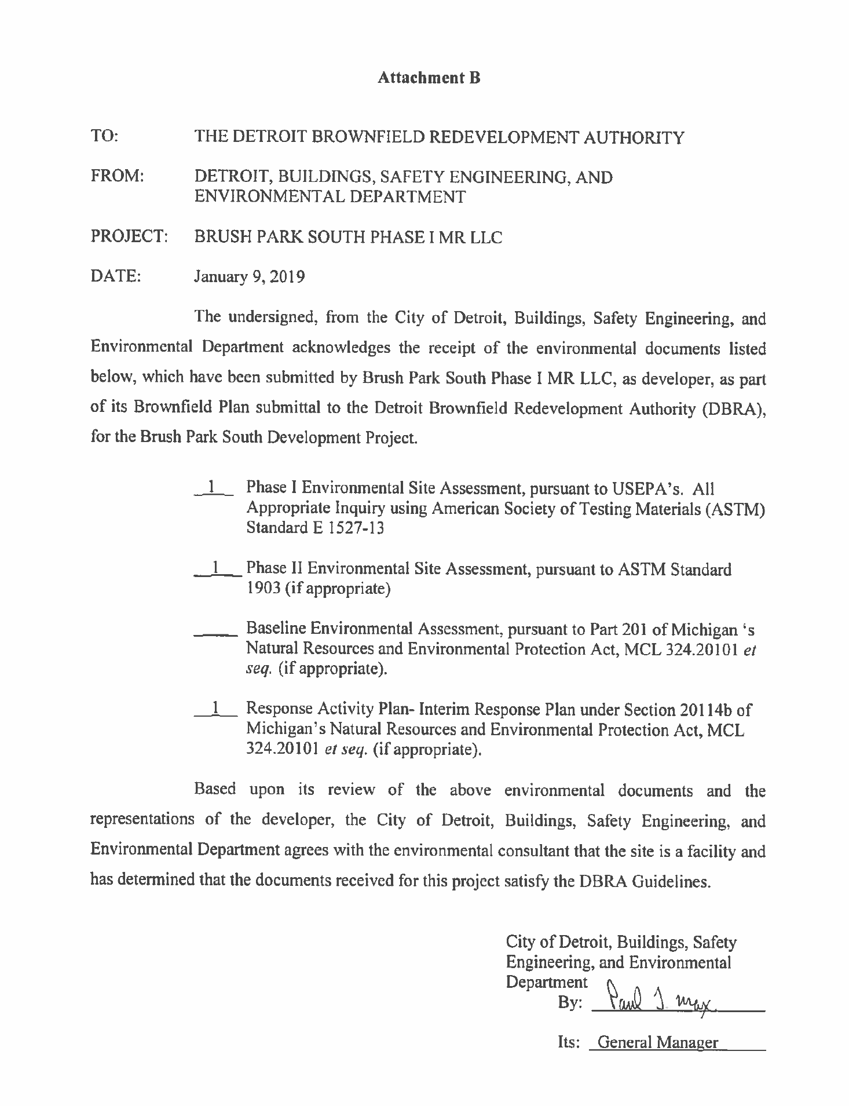

**MDEQ Facility Confirmation**

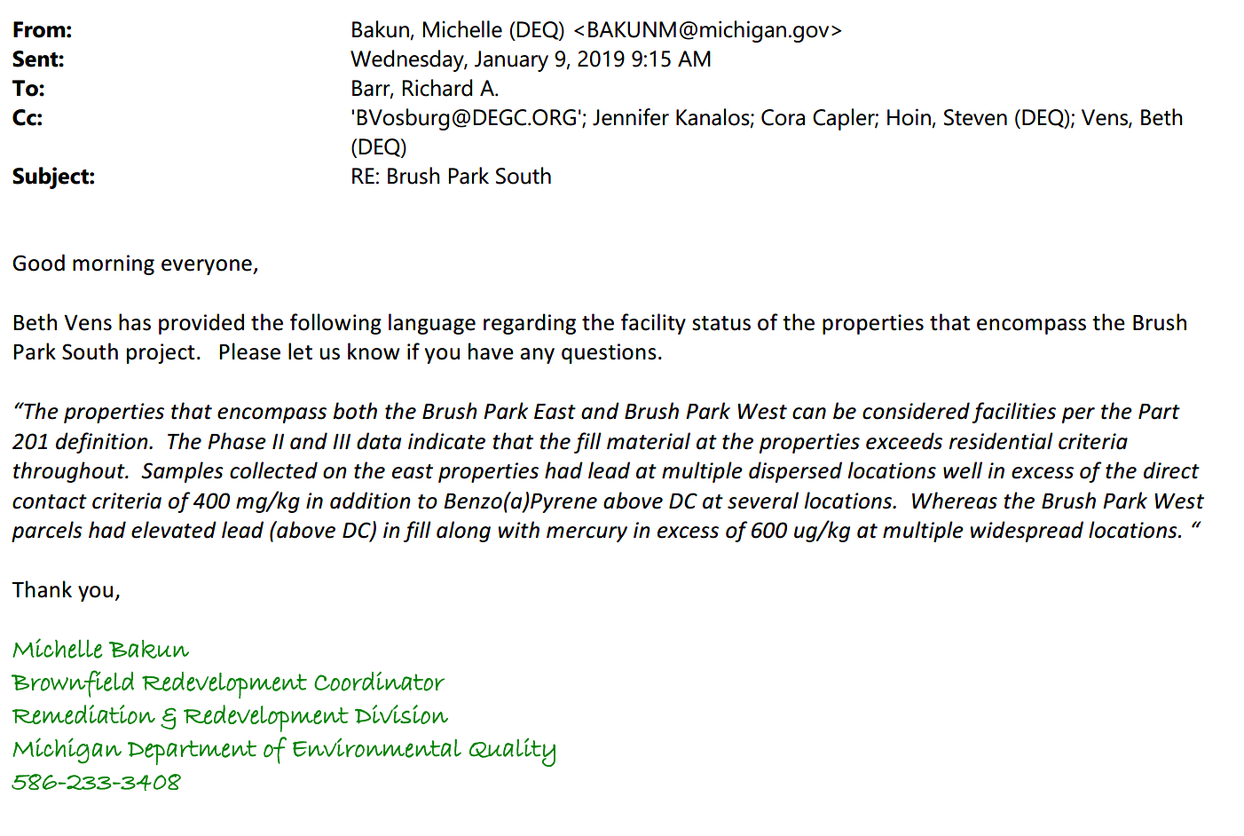

**ATTACHMENT H**

**INCENTIVE INFORMATION CHART**

|  |  |  |  |
| --- | --- | --- | --- |
| **Project Type** | **Incentive Type** | **Investment Amount** | **District** |
| Mixed use residential/commercial | Brownfield plan and PA 210 | Approx. $37,000,000 | 5 |

|  |  |  |  |  |  |  |  |
| --- | --- | --- | --- | --- | --- | --- | --- |
| **Jobs Available** | | | | | | | |
| **Construction** | | | | **Post Construction** | | | |
| Professional | Non-  Professional | Skilled Labor | Non-Skilled Labor | Professional | Non-  Professional | Skilled Labor | Non-Skilled Labor |
| 10 | Combined 240  240 | | | 1 | 1 | 2 |  |

1. What is the plan for hiring Detroiters?

The developer and its general contractor will work with the DEGC, DESC and local subcontractors to recruit Detroit residents for construction and permanent jobs. Information and assistance with be sought from the City as well.

1. Please give a detailed description of the jobs available as listed in the above chart, i.e: job type, job qualifications, etc.

Construction jobs will consist of the customary range of skilled labor jobs and other jobs. Permanent jobs will include leasing and property management positions.

1. Will this development cause any relocation that will create new Detroit residents?

No.

1. Has the developer reached out to any community groups to discuss the project and/or any potential jobs?

The developer has engaged with the Brush Park community throughout the multi-year project development process.

1. When is construction slated to begin?

February, 2019

1. What is the expected completion date of construction?

Occupancy by December, 2020 and final punch list completion by early 2021.